
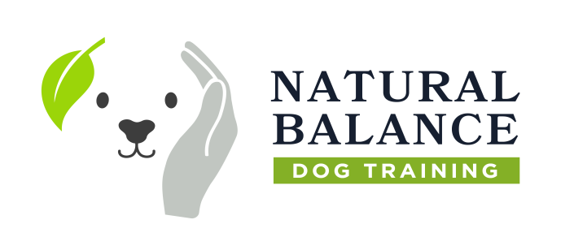


This is to certify that

Carolynne Amey

has successfully completed the

Dog Behaviour Academy
Essential Dog Psychology and Behaviour Modification Skills
and as such is now a fully qualified
Dog Behaviour Specialist



Natural Balance Dog Training LTD

Signature of Instructor Sarah Easterbrook Date 5th February 2024

